**Assignment 7**

**Name – SURAJ KUMAR YADAV**

**ROLL NO. – 20220PHY014**

1. **Design a master slave JK flip flop, show the output for J = 1, K = 1**

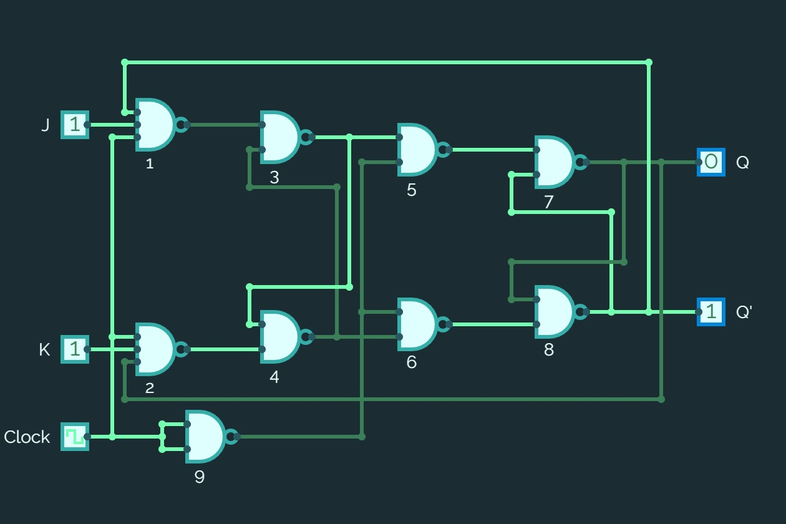

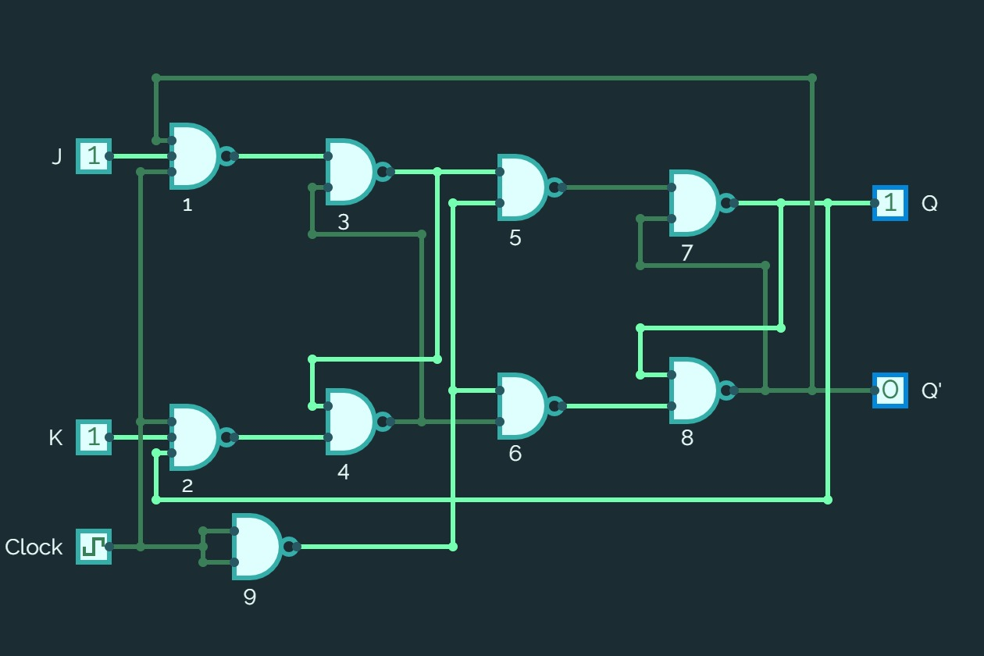

1. **Consider the sequential circuit using D flip flop shown in pdf file number 3.3. Analyze the circuit behavior for the given inputs.**

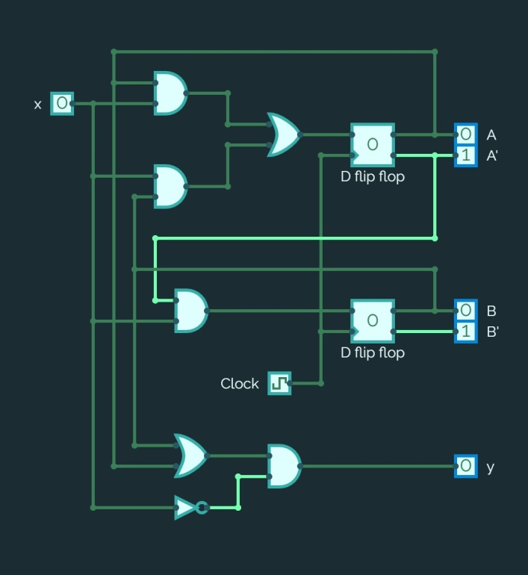

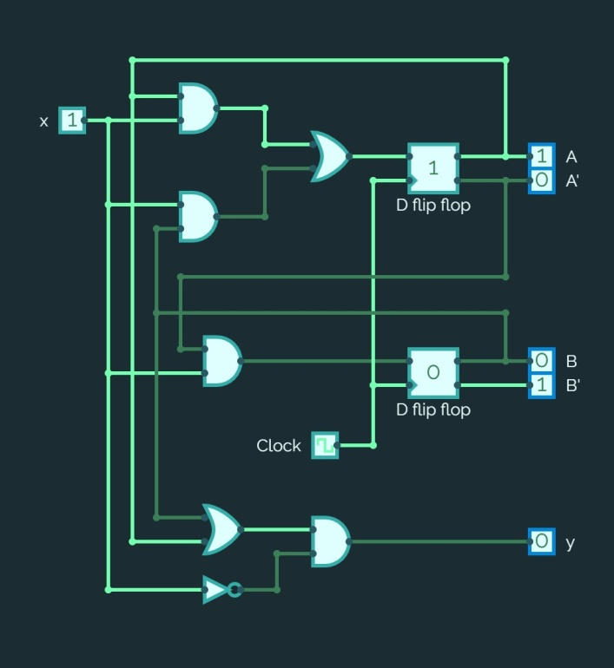

1. **Consider the sequential circuit using JK flip flop shown in pdf file number 3.3. Analyze the circuit behavior for the given inputs.**

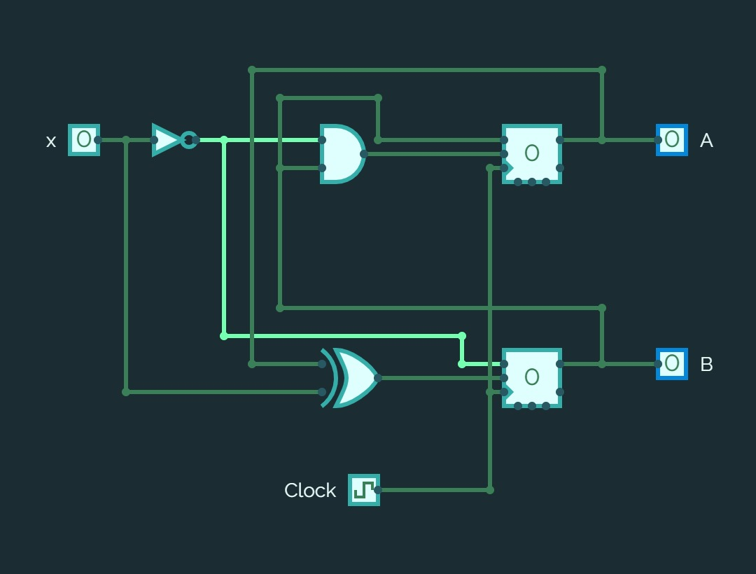

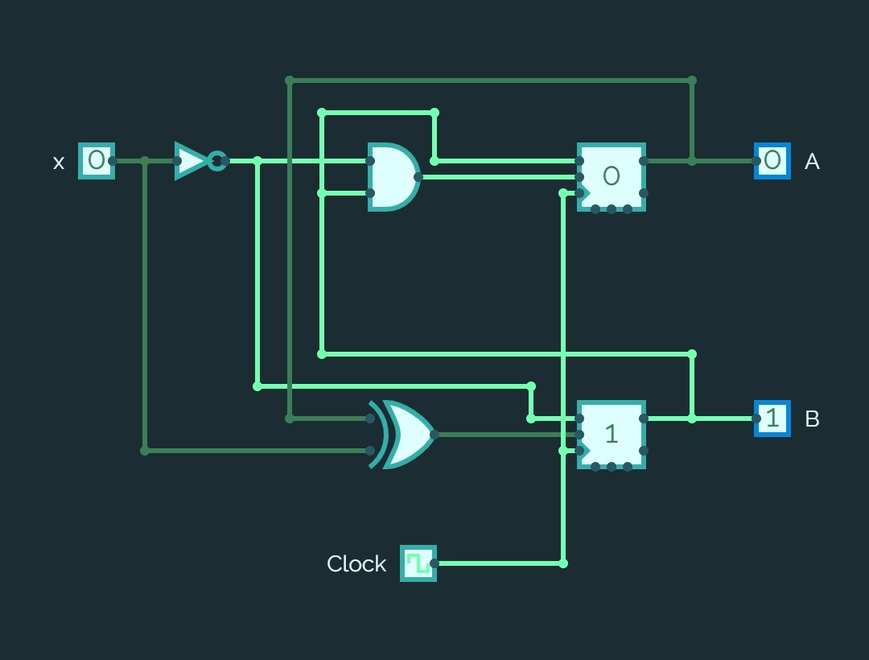

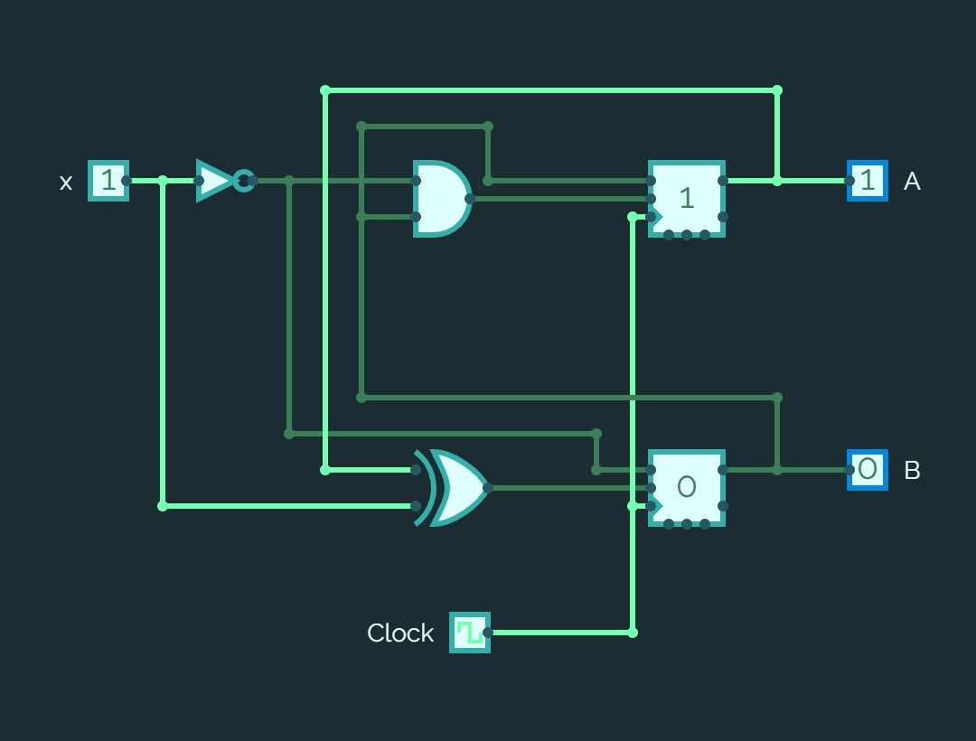

1. **Verify the circuit excitation table for**
   1. **RS flip flop**

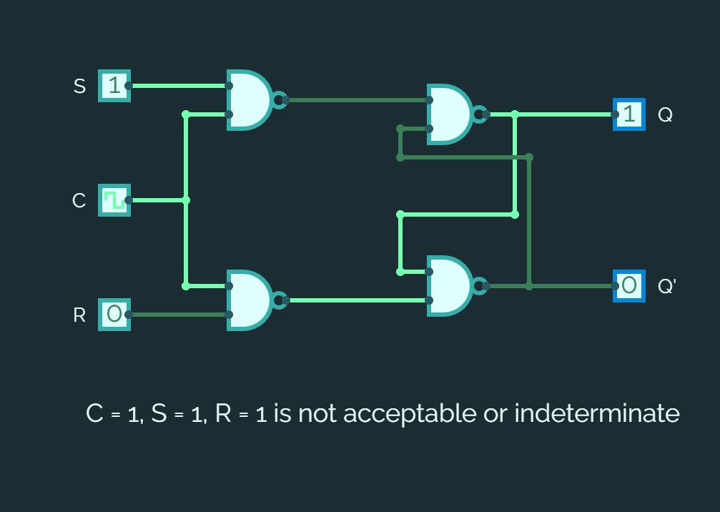

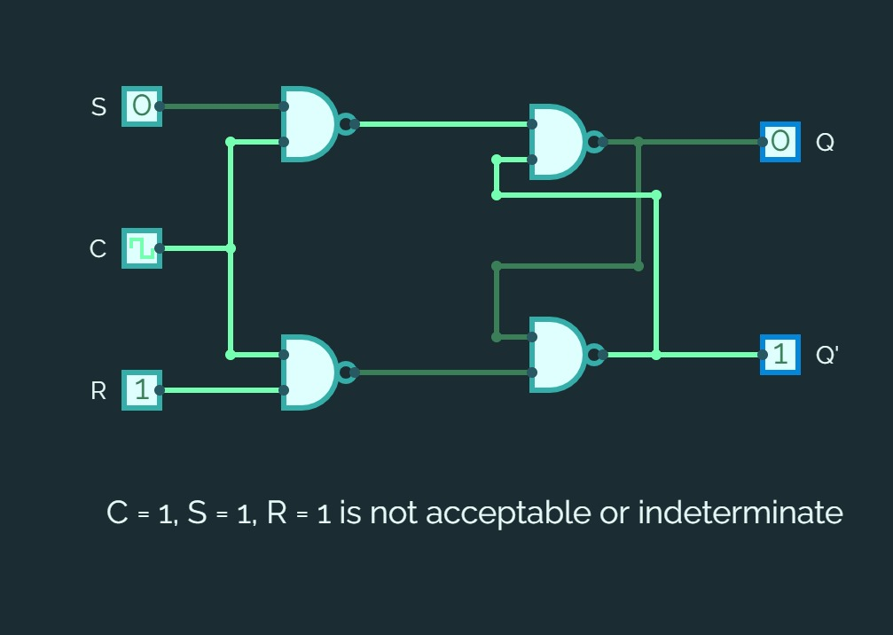

* 1. **JK flip flop**

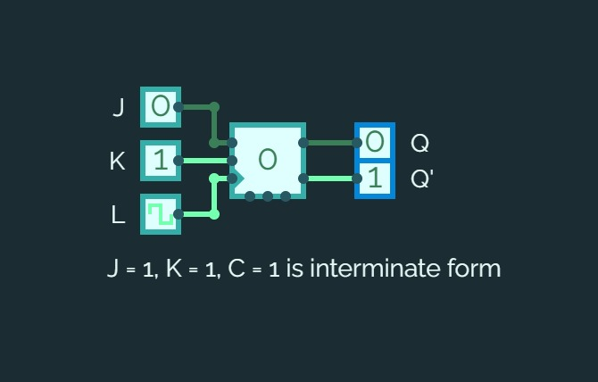

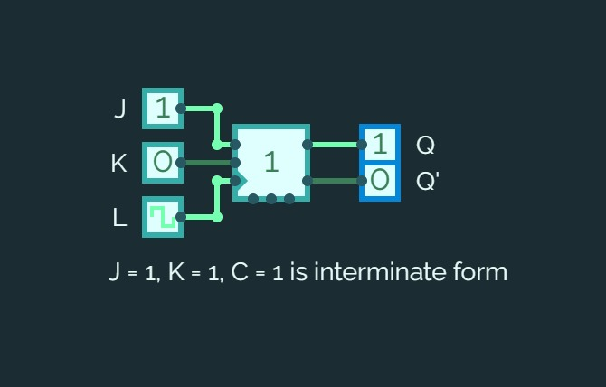

* 1. **D flip flop**

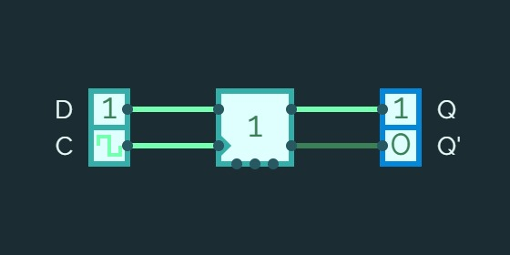

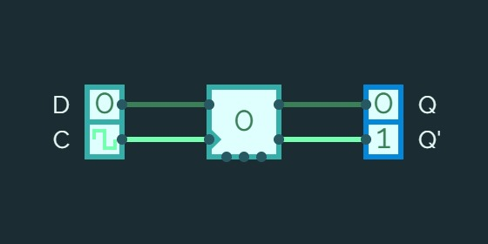

* 1. **T flip flop**



